Logbook
28-02-2020 Decided project subject: Collecting floating trash.
06-03-2020 Finished Design Thinking course.
13-03-2020 Decided our project product: Water bin.
08-04-2020 Uploaded Interim Report and Presentation.
16-04-2020 Interim presentation.

Weekly Report

1st Week Report (2020-02-17)
The school schedule was presented, the project groups were formed and we had a teambuilding day. For this day we came up with two teambuilding activities: Spiderweb Game and Ninja Game. The project group also made a top 3 of proposals subjects for the project: 1. Smartification of everyday objects, 2. Indoor blimp and 3. Smart hand.

2nd Week Report (2020-02-24)
Monday and tuesday were holidays, because of carnival. The first classes of Project Management, Marketing, Communication, Energy & Sustainability and Portuguese were taught. During a class of Communication we presented the cultural similarities and differences in our project group. Also, there was a meeting with the teachers about our project process. During this meeting we presented our project ideas. We apologized for not updating our Wiki (Home, Weekly Report, Agenda and Report) and we will make sure to update the Wiki next week. On friday we decided on our project subject: Collecting floating waste.

3rd Week Report (2020-03-02)
We followed a Design Thinking course taught by Cláudia Facca from Brazil. We ended the course by creating a video about our product [https://www.powtoon.com/c/bg6gAOHaIVi/1/m] and creating a very rough prototype made of carton, as seen in Figure . Also, we had our first Technology Course. During this course, we learnt about the basics of the programming language Python. Furthermore, we did a presentation during the class Communication about our project subject and we presented our cultural curiosities during the Portuguese class.
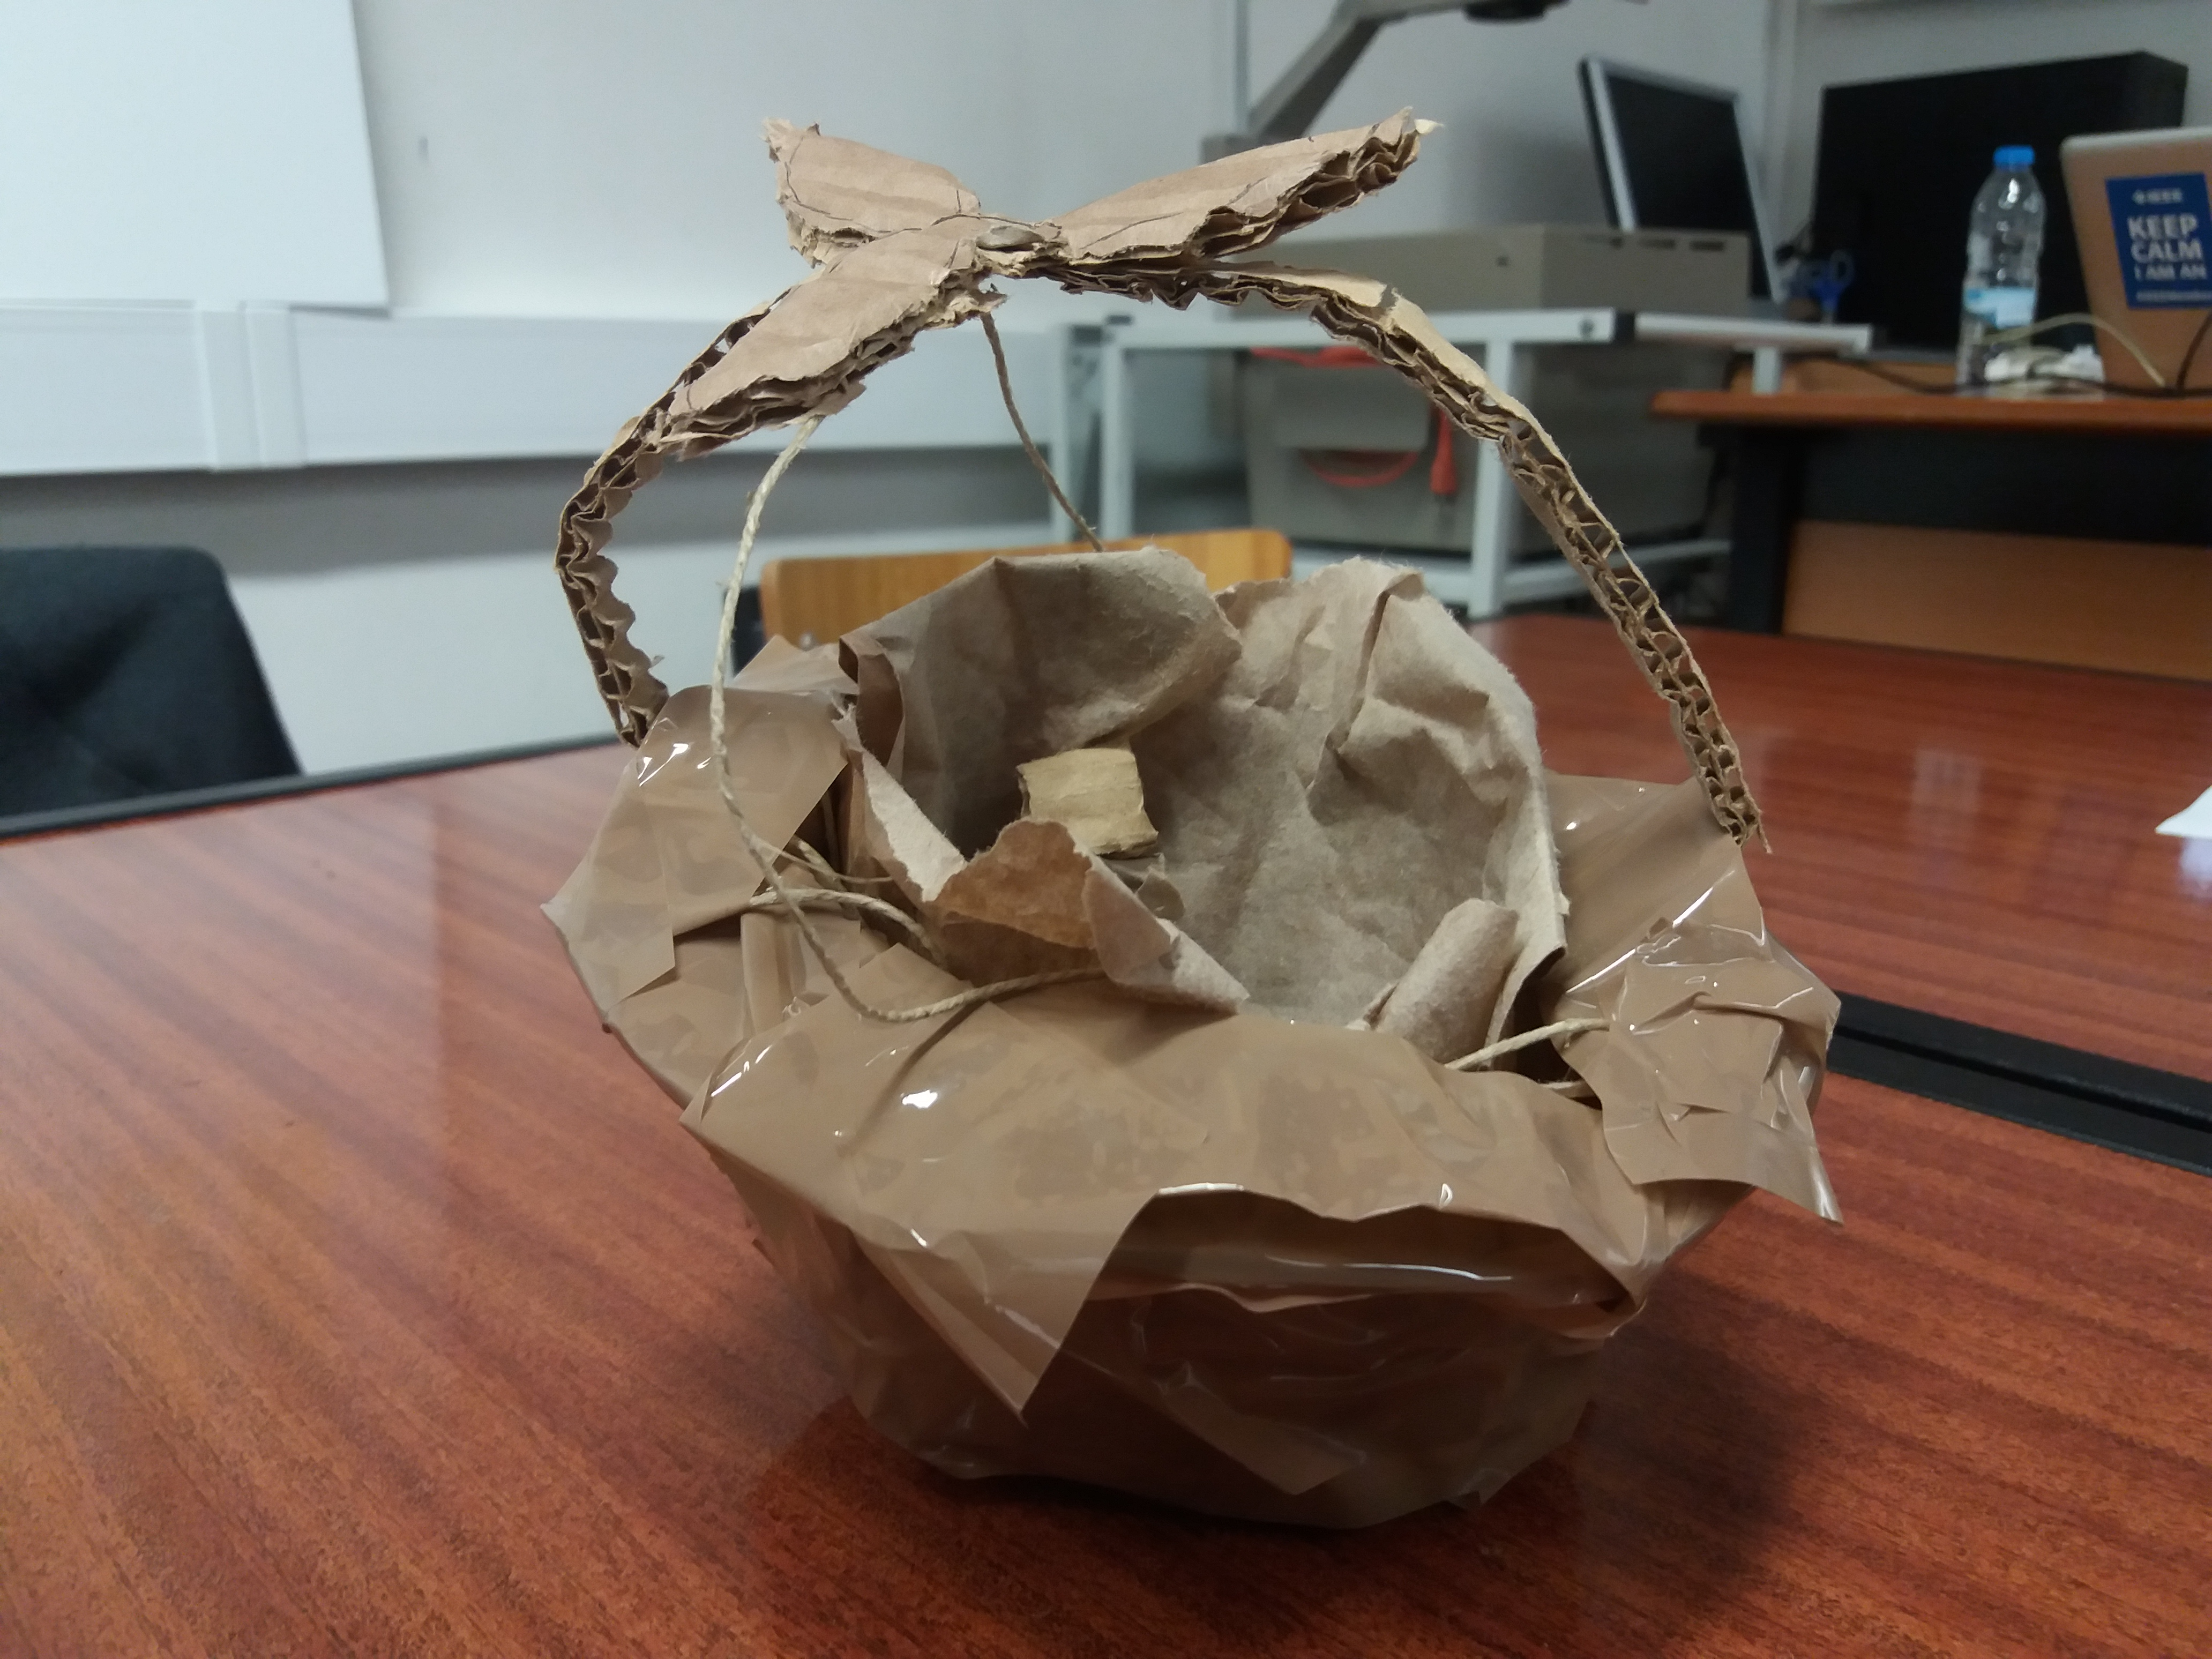
Design Thinking cardboard prototype

4th Week Report (2020-03-09)
We have planned our activities and started our first sprint. We have thought of another way of collecting the trash by making a barrier. Thursday and Friday ISEP was closed, because of the coronavirus. ISEP will be closed at least for the rest of the month (might open in the 7th week). Our meetings continued via Skype.

5th Week Report (2020-03-16)
The classes via video calling started this week. We continued working on the report. Also, we talked a lot about the situation with the coronavirus and how we are going to handle our project.

6th Week Report (2020-03-23)
We worked on the schematics for the electrical circuit. Also, we did research and worked on some chapters of the report: Marketing, Sustainability, and Ethics. We had our first online Sustainability class.

7th Week Report (2020-03-30)
We revised the first chapters and worked further on Marketing, Project Management, Sustainability, and Product Development. We also worked on the interim presentation.

Easter Break (2020-04-06)
-

8th Week Report (2020-04-13)
This week we presented the interim report. After the presentation the interim report was made available with suggestions for correction by the teachers.

9th Week Report (2020-04-20)
This week we have made corrections to the report, flyer and leaflet, according to the feedback received last week. Also, Ana Barata explained us how to start with our paper. In the Ethics class, we did a presentation about the Fyre Festival.

10th Week Report (2020-04-27)
In Portuguese class, we had an interim test Portuguese. Furthermore, we continued working on the report and we emailed Ana Barata the introduction, problem statement and state of the art for the paper.

11th Week Report (2020-05-04)
This week was supposed to be the Student Week Break, but this was cancelled. In a meeting with Luis Lopes, we received clear feedback for the Marketing and Ethics chapter. Moreover, we handed in our refined interim report.

12th Week Report (2020-05-11)
We made a lot of progress on the IoT platform and we started using the Microsoft Planner for our sprint plannings.

13th Week Report (2020-05-18)
We worked further on the paper and applied the feedback we received from professor Luis on the Marketing chapter.

14th Week Report (2020-05-25)
We created the poster and applied the received feedback from professor Ana to it. Also, we started copied our paper from the word document on OneDrive to Overleaf.

15th Week Report (2020-06-01)
We refined the Soaksy App on the Internet of Things platform, worked further on the paper and applied professor Ana's feedback to it and refined our report, poster, leaflet, flyer and user manual.

16th Week Report (2020-06-08)

17th Week Report (2020-06-15)

18th Week Report (2020-06-22)

Meetings

1st Meeting (2020-02-20)

Agenda:
- Presentation
- Modus operandi
- Project proposals
- Electronic logbook (Wiki)

Minute:
All the EPS students were gathered. The school schedule, the project proposals, the teachers and the teachers were presented.

2nd Meeting (2020-02-27)

Agenda:
- Presentation of our project ideas
- Wiki

Minute:
We presented our five ideas for the project: Smart food heater, recycling paper into objects, reuse water from bathroom, smart bookshelf, garbage bin for the sea. We should try to choose either a new idea or improve an existing one. Regarding the ocean cleaner, the stirling engine was presented to us. Also, we got a warning. We will update our Wiki before our next meeting.

3rd Meeting (2020-03-05)

Agenda:
- Logbook
- State of the Art
- Backlog, Sprint Plan and Gantt Chart
- Black Box Diagrams and Structural Drafts

Minute:
In our logbook we will write down what we have accomplished on what date. This week we started writing the State of the Art. Professor Benedita explained us how the citation in the bibliography works. Today we will finish the Backlog, Sprint Plan and Gantt Chart with professor António, our Project Management teacher. Next tuesday is the deadline for the Black Box Diagrams and Structural Draft. Professor Benedita explained us these have to be written in subchapter 7.2 Architecture of chapter 7 Project Development.

4th Meeting (2020-03-12)

Agenda:
- Black Box Diagram
- Structural Drafts
- Advice about the structure/technology of our product
- Planning section (our idea/structure of the sprint plan)

Minute:
According to Benedita, the triangle shape barrier is easier to keep than the C-shaped barrier, because the flow in the river is stronger in the middle. On the contrary, collecting trash is easier with the triangle than with the C-shaped barrier. Benedita said it is not necessary to improve a product, we can also make it cheaper, simpler, more autonomous, etc. What we should do now: Choose the type of product we are aiming to create, finish the Introduction and State of the Art in the report, continue writing other chapters in the report, reorganize the Black Box Diagram and improve our Structural Drafts. Our Structural Drafts look more like concept drawings, because a structure is not visible in it now.

5th Meeting (2020-03-19)

Agenda:
- Effects of coronavirus on EPS
- Soaksy
- Flyer
- Black Box Diagram
- Structural Drafts
- Technical aspects

Minute:
The EPS project will continue, there might be effects on the prototype: in some cases, we will not be able to build the prototype and if so, we need 3D modeling and tests. The flyer is good, we may need to change the bottle image and make it look crumpled because it suggests advertising for a drink.

6th Meeting (2020-03-26)

Agenda:
- Sustainability chapter
- Electrical circuit
- Deadline Interim Report

Minute:
We showed the teachers the updated flyer and leaflet. We were asked to upload those on the wiki. The Sustainability chapter will be discussed tomorrow during the class Energy and Sustainability. Discussion on the electrical circuit, more notably the power options of the system and pump properties. The deadline of the Interim Report is on the 8th of April, so we should work on writing the report, work on the final drawings and start developing the 3D model. Everything has to be available on the wiki for the teachers to see.

7th Meeting (2020-04-02)

Agenda:
- Project Management chapter
- Product Proposal
- List of Materials
- Interim Report deadline

Minute:
Before the deadline of the Interim Report on the 8th of April, we should be as far with the report as possible. In the Project Management chapter we can add the global sprint plan, backlog, the weekly sprint plans and the gantt chart. The product proposal can be added at the beginning of the Project Development chapter. This proposal consists of sketches, models and a text that explains the requirements of our prototype based on the previous chapters. We also discussed the List of Materials we created so far. The List of Materials can also be added to the Project Development chapter. Since Patrick left our project group on the 12th of March, he is deleted from EPS@ISEP. For the work he has done, we give him credits in our report.

8th Meeting (2020-04-16)

Agenda:
- Interim presentation
- Professors feedback

Minute:
At this meeting the team held the Interim Presentation, demonstrating the progress of the project so far. After the presentation, the team received feedback from the teachers.

9th Meeting (2020-04-23)

Agenda:
- Change in the functionalities
- Power budget
- Black Box diagram
- Structural drawing
- Material properties
- Final video of the 3D model

Minute:
We have submitted corrections to the report according to the feedback given last week.
The team also made proposals for features and teachers gave feedback.

10th Meeting (2020-04-30)

Agenda:
- Final video of the 3D model
- Sensors

Minute:
We showed the final video of the 3D model. The supervisors liked it, but think there are some things missing:
- The sensors
- Showing how the Soaksy works: How does the Soaksy collect trash and how is the Soaksy emptied?
- A voice over that explains what is shown in the video
Benedita thinks the fixed system is not a good idea, because of the difference of the water height during the year. Sometimes, in extreme circumstances, the water height riser or lowers even two meters. To solve this problem there were two ideas:
- Make the inner part of the water bin of floating material, for example cork.
- Make the Soaksy attached to a pole in the ground instead of attach to the land. Like a floating dock.
The sensors will be for alerting full capacity, but where to place the sensors? Ideas:
- Triangle, horizontal bar, sensor in small box, small battery, small system to use wifi. Would be most techy solution.
- Exactly on the top of the vertical bar. Problem: Bar and bin are not floating together.
- A ring on the vertical bar, because that floats with the water. Only alert if the sensors give positive for full capacity for a longer time, otherwise false positives will happen.
How to simulate the Soaksy:
- Define a data structure for IoT platform
- Create a mock up for IoT platform
- Develop the app for data storage and full capacity alert on IoT platform
- Use Kikad to simulate whatever is possible
Our project will probably be shown on the TEEM conference. It is not clear yet if our paper will be written in LaTeX/Overleaf or Word. For now, we stick to LaTeX/Overleaf.
The student break is cancelled.

11th Meeting (2020-05-07)

Agenda:
- Change to the overall design
- Packaging solution
- Raising awareness

Minute:
We presented the petal-shaped cork stabilizers for the design and it is a good idea that the bin floats freely, but we should consider:
- that the petals might break because there is nothing to increase their strength
- to calculate the weight of the bin and if it floats
- if we need any additional weight
- redesigning the floating petals
For the packaging solution, we might want to consider reusable packaging, since the package would be relatively big.

12th Meeting (2020-05-14)

Agenda:
- Packaging solution
- Who empties the Soaksy?
- Simulation electrical circuit
- 3D model ideas
- Do we still have the 100€ budget?

Minute:
For the packaging solution, we did a good research. Now we should decide which of the options we found is the best one and design the package, i.e. create a small video. Also, it is important that our package is reusable and recyclable.
Who empties the Soaksy depends on the weight of the inner bin and the collected trash inside. If it is light, one or two people on land could empty the bin. If it is heavy, a trash truck should empty the bin.
For the simulation of the electrical circuit, we started working on Internet of Things.
We gave up on the cork in our design, because the cork was vulnerable and needed a lot of plastic as support. In our design, we now use hollow plastic paddles.
Yes, we do still have the 100€ budget.
For the next meeting, all details of our product should be provided, i.e. dimensions, volume inside, level of the water and so on.

13th Meeting (2020-05-21)

Agenda:
- Water resistant packaging solution?
- Final 3D model, dimensions of final product or prototype?
- Expectations list of materials
- Project Development for the final product
- Simulation circuit vs prototype circuit

Minute:
The dimensions should be calculated for the final product, and then specified the scale of the prototype. For the list of materials, for the materials can be found as a final component to buy, it is better that we consider those prices. Otherwise, we can use the price of raw materials.

14th Meeting (2020-05-28)

Agenda:
- Functional Simulation Results: Electrical Circuit and IoT
- Packaging Solution update
- 3D Model update
- Suppliers for the raw materials (for example polyethylene)

Minute:
We need to show the calculations that led to the final model. For the raw materials, it is a good idea that we calculate the final price by considering the mass of that certain material and the price per kg.

15th Meeting (2020-06-04)

Agenda:
- Paper Personal Outcomes
- Final design discussion
- Final simulation circuit
- Dashboard IoT platform

Minute:
For the personal outcomes in the paper, every team member writes about his/her learning experiences and distance learning experience.
We should email professor Benedita when we applied professor Ana's feedback to the paper. Professor Benedita will then give us feedback.
Professors Jorge and Benedita suggested the following about the final design:
- You can increase the volume (not the area) of the blue paddles.
- Use a cable that would sustain some weights outside.
When it comes to the circuit simulation and IoT dashboard, the following feedback was given:
- Change the display name of the situation with no data available.
- Send motor state to the online dashboard.
- Test the condition of the failure of the water level sensor.
The next weekly meeting will be on Tuesday instead of Thursday, because of the Portuguese holiday.

16th Meeting (2020-06-09)

Agenda:
- Final presentation
- Deadlines on the 19th and 23th of June
- Discussion of the user manual

Minute:
The time limit for the final presentation is 10 minutes. Focus in the presentation on the solution. This means, explaining your thought process and the choices you made for the design and for how the product works. Your thought process or choices can be based on ethics, sustainability and marketing. After the presentation, you can show your final video. This has a time limit of 2 minutes.
Professor Benedita has not decided yet what exactly happens on the deadlines on the 19th and 23th of June. Later, she will email us about these deadlines. For the final presentation and individual discussion/assessment on the 16th of June, make sure to reserve the whole day!
The user manual design looks okay, according to the supervisors. They did not look closely to the content. Professor Benedita did comment that all titles should be in the same font and size. Make the user manual readable and understandable or make it short. Decide as a team which one you want.
We should continue working on the paper and make sure it is finished this friday. Also, everyone should fill in the mandatory self-critique questionnaire sent by email.

Activities
Please register here all accomplished project activities
Start | End | Task | Description | Who

